Get current logged in user name command line_CMD

# whoami



# Query user

Exemplo:

c:\>**query user**

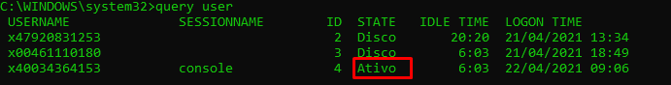

cmdline\administrator

# Referências

[1] WINDOWS COMMAND LINE. **Get current logged in user name command line (CMD)**. Disponível em <<https://www.windows-commandline.com/current-logged-in-user-name-command/>>. Acessado em 09/04/2021

[2] PASSWORD RECOVERY. **How to See Currently Logged in Users in Windows 10 / 8 / 7**. Disponível em <https://www.top-password.com/blog/see-currently-logged-in-users-in-windows/>. Acessado em 22/04/2021